Ideation Phase
Brainstorm & Idea Prioritization Template

Date | 13 October 2026
Team ID
Project Name | Metro Ticket Generating System in ServiceNow
Maximum Marks | 4 Marks

Step-1: Team Gathering, Collaboration and Select the Problem Statement

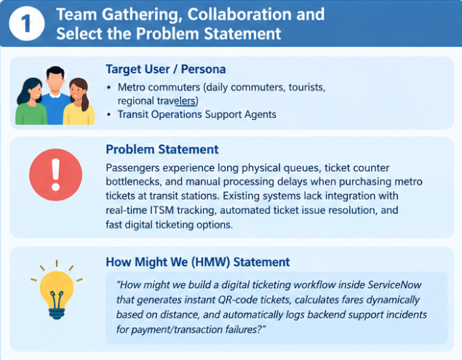

Step-2: Brainstorm, Idea Listing and Grouping
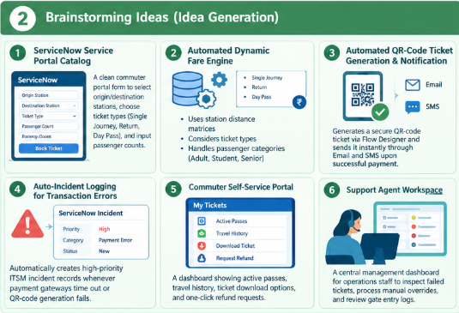

Step-3: Idea Prioritization

